

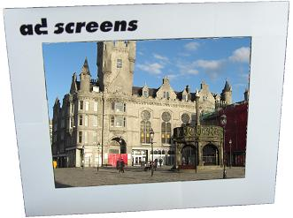  Communicator I & IV | Communicator Adscreens  Communicator Adscreens are fixed position LCD screens with video and still images media player built-in, plus optional LED Scroll Bar.  Features:  - visor to protect LCD  - brand customising area on visor  - Auto-run of Jpeg or Mpeg media files  - Internal memory storage for media files  - Stereo audio  - 7-day Programmable On/Off times  - Easy wall mounting plus VESA standard fixings
Communicator Adscreens allow you to broadcast your own media content, customised to each screen location if required with 7-day time schedule (by day and time of day).  Media files are held in the screen memory and retained with power off.  Video media file types supported include Mpeg1/2 up to 720x576 PAL and 720x480 NTSC ,plus Jpeg image files and MP3 audio files. All files are played in endless loop. Media can be loaded to the screen with a USB drive, or a flash card (many types are supported), and ‘copied’ to the screen internal memory. Alternatively media files can be transferred by USB lead with a laptop.  Communicator I (entry level) TFT LCD  Communicator II TFT LCD with LED Scroll Bar  Communicator III TFT LCD with GSM SMS messaging  LED Scroll Bar  Communicator IV TFT LCD Network Media Player |  | 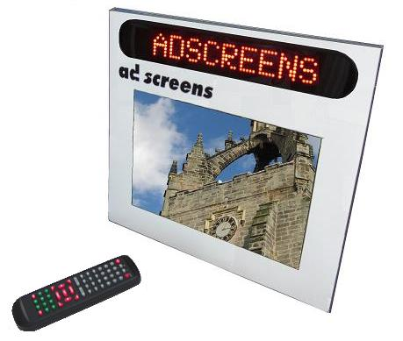  Communicator II & III

Technical Details

Model / Description
Communicator I (entry level) TFT LCD | 15” TFT LCD Stand Alone Media Player. Media files can be stored in Internal memory or Flash memory cards or USB Drive. Media formats supported include MPEG 1 (VCD), MPEG2 (DVD), MPEG 4, Motion JPEG, MP3, JPG (files up to 12Mega pixels). Memory cards supported include: CF, SD, MMC, xD and MS. Screen resolution 1024 x 768. Brightness 450cd.
Communicator II TFT LCD with LED Scroll Bar | As above specification plus LED 50x7 matrix text scroll bar programmable by IR Remote Control. Up to 9 messages can be stored, each with maximum of 250 characters.
Communicator III TFT LCD with GSM SMS messaging LED Scroll Bar | A above specification, plus the ability to send GSM Text (SMS) messages directly to the LED Scroll Bar.
Communicator IV TFT LCD Network Media Player | 15” TFT LCD Network Media Player. Media files can be stored in Internal memory or Flash memory cards or USB Drive. Media control software included, media files are loaded via network connection, together with scheduling information.  Media formats supported include MPEG 1 (VCD), MPEG2 (DVD), AVI, MOV, SWF, VOB, JPG. Memory card supported: Compact Flash.
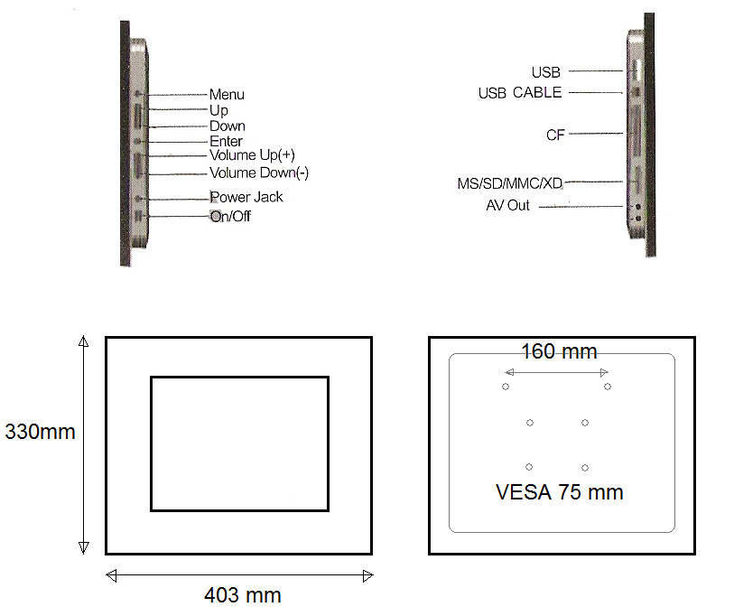
Communicator I, Outline Drawing

